**Homework 4: Introducing functions**

1. Which **two** of the following statements are correct? [2]

⬨ Functions are blocks of code that can easily be reused

⬨ Functions make your code longer and more complex

⬨ Functions are essential and every computer program must include at least one

⬨ Functions can make it easier and quicker to update a program in the future

2. Examine the following code:

def addNumbers():

num1 = int(input(“Enter first number: ”))

num2 = int(input(“Enter first number: ”))

print(“Total =”, num1 + num2)

def squareNumber():

num = int(input(“Enter a number: ”))

print(“Number squared =”, num * num)

**(D)**

print(“============”)

print(“Main Menu”)

print(“1. Add two numbers”)

print(“2. Square a number”)

print(“3. Quit”)

def quitMessage():

print(“Goodbye!”)

# MAIN METHOD

choice = 0

while choice != 3:

displayMenu()

choice = int(input(“Enter your choice: ”))

if choice == 1:

**(A)**

elif choice == 2:

**(B)**

elif choice == 3:

**(C)**

else:

print(“Error, invalid choice”)

(a) Write the piece of code that should appear at the point marked **(A)** [1]

(b) Write the piece of code that should appear at the point marked **(B)**  [1]

(c) Write the piece of code that should appear at the point marked **(C)** [1]

(d) Write the piece of code that should appear at the point marked **(D)** [1]

3. Examine the following code, part of a turtle drawing program:

def square(size):

for counter in range(4):

turtle.fd(size)

turtle.rt(90)

def shape(sides):

for counter in range(sides):

turtle.fd(100)

turtle.rt(360/sides)

# MAIN METHOD

square(100)

square(75)

square(50)

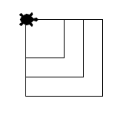

1. Write one more line of code that would produce the following output [1]

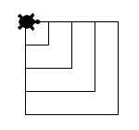

(b) Write line of code that would produce a hexagon (six sided shape) [1]

(c) Write the main method that would produce the following shape [4]

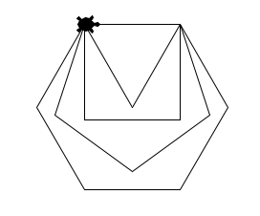

[Total 12 marks]